**1. Temperature and Humidity Sensor - DHT** 11

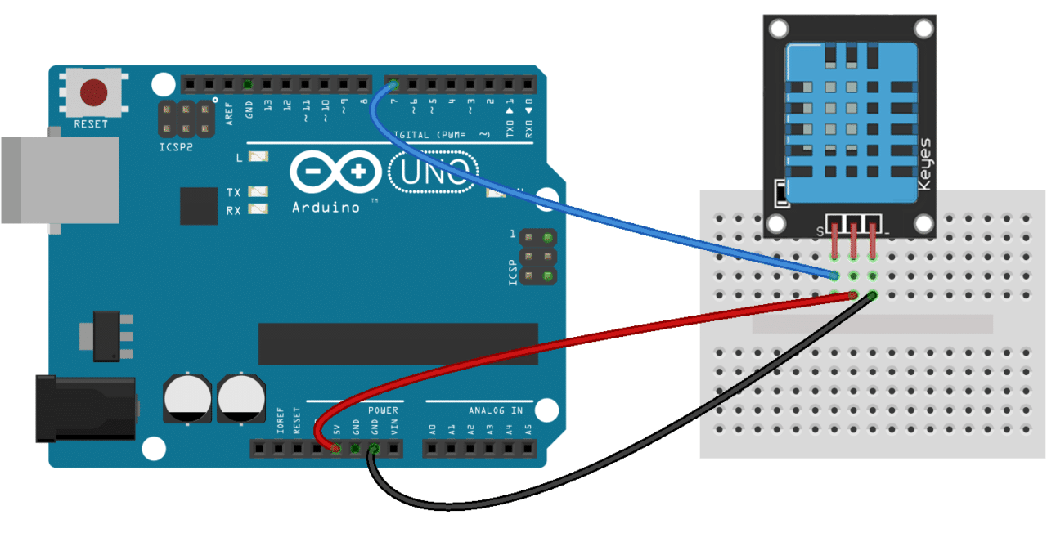

* DHT11 is interfaced with Arduino shown above using jumper wires
* Once it is successfully interfaced, connect the arduino board to the laptop with a USB cable
* Open Arduino IDE and include the “dht library file” by pressing on

→ Sketch

→ Include library file

→ DHT on the top left corner.

* Type the given code, compile and upload

#include <dht.h>

dht DHT;

#define DHT11_PIN 7

void setup()

{

Serial.begin(9600);

}

void loop()

{ int chk = DHT.read11(DHT11_PIN);

Serial.print("Temperature = ");

Serial.println(DHT.temperature);

Serial.print("Humidity = ");

Serial.println(DHT.humidity);

delay(1000);

}

* After uploading check the temperature and humidity value by clicking on

→ Tools

→ Serial monitor

**2. Bluetooth - HC05**

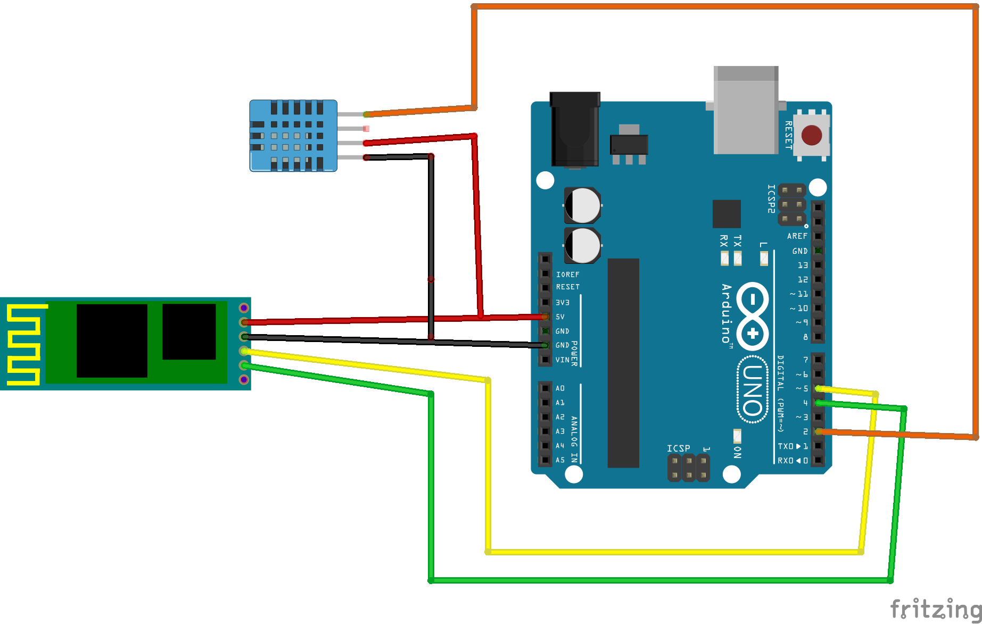

* Connect HC05 bluetooth to arduino as shown above along with the temperature sensor DHT11
* Download the app **Bluetooth Terminal HC05**
* In the app give bluetooth access and press on scan
* Select our interfaced device and enter pin i.e, either 0000 or 1234
* After pairing the device press the

→ Tools and → Serial monitor on Arduino IDE

* The temperature and humidity value is now displayed on to the app

